Reports
​

​
Nirolite has 4 financial reports. Each report is calculated using the General Ledger Entries that are created when any Transactional Entry is made.

Sections
All reports have two sections:
- Filter Section
- Report Section
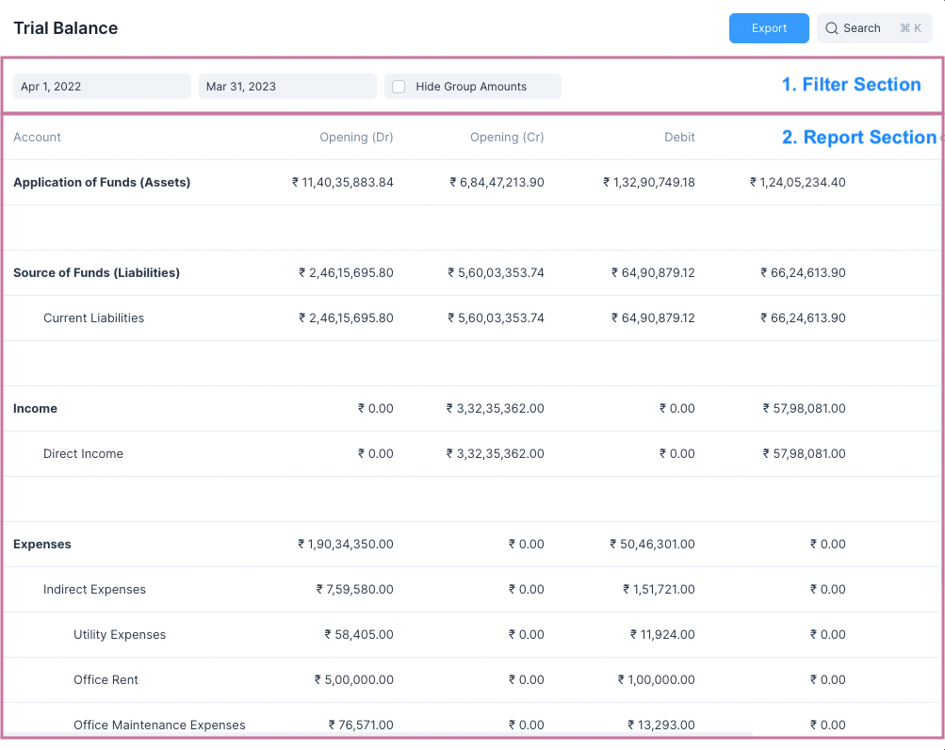
The Filter Section allows for setting filters such as the Date Range between which a report is to be generated.
::: tip Setting Filters To generate a report after setting a filter, just click outside the filter box. :::
The Report Section shows the generated report.
::: info Pagination The General Ledger report also shows a paginator at the bottom which allows for viewing only sections of the report. :::

Exporting a Report
All reports can be exported as a CSV or a JSON file. To do so just click on the blue Export button and select the file path.
After exporting the report you may open it in any software of your choice such as Libreoffice Calc, Google Sheets or Microsoft Excel.

Report Links
Check the following links to understand these reports:
- General Ledger
- Profit and Loss
- Balance Sheet
- Trial Balance

Trial Balance
​

​
A Trial Balance is an accounting report which lists account balances for all your Accounts (both Ledger and Group) for any given reporting period.
A company prepares a trial balance periodically, usually at the end of every reporting period. The general purpose of producing a trial balance is to ensure the entries in a company's bookkeeping system are mathematically correct.
The totals of Debit and Credit columns must be the same for any given period, to ensure the entries are correct.
Navigate to this report from the sidebar: Reports > Trial Balance
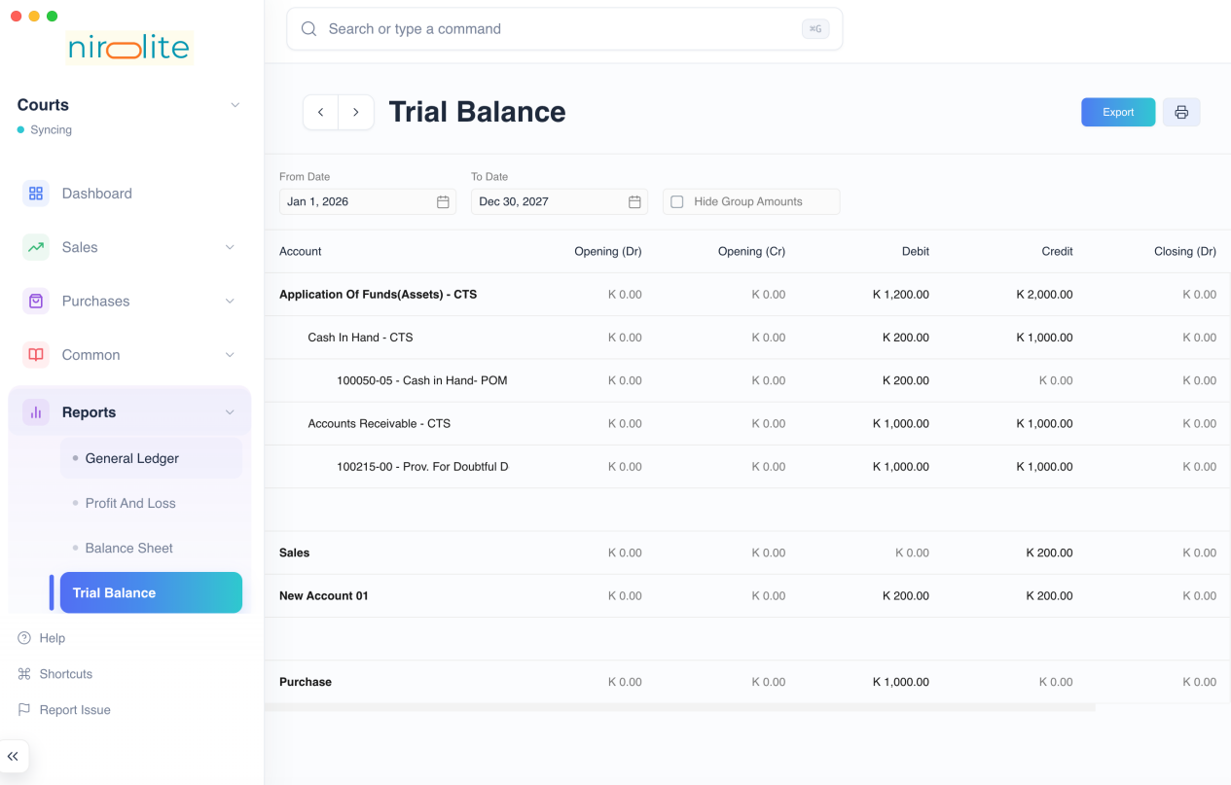

Filters
The Trial Balance report has filters which can help you narrow the date range between which to display the report.

From Date
The initial date after which the Trial Balance has to be calculated. The default value is the first day of the current fiscal year.

To Date
The final date before which all the Trial Balance has to be calculated. The default value is the last day of the current fiscal year.

Hide Group Amounts
The Trial Balance report format displays the group accounts such as Current Liabilities along with the non group accounts such as Secured Loans and Creditors.
Group account balances depend on the non group account balances under them, group account balances are not directly updated.
So clicking on Hide Group Amounts will display only the non group account amounts making the report a bit easier to read.

Folding Rows
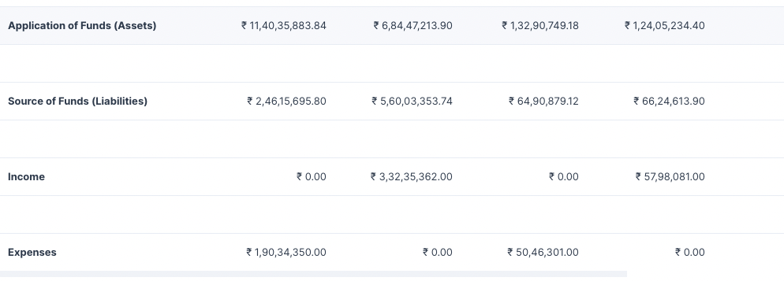
Rows in the Trial Balance report which display group accounts can be clicked to fold all the rows underneath them.

General Ledger
​

​
The General Ledger is a detailed report for all transactions posted to each account and for every transaction there is a Credit and Debit account so it lists them all up.
This helps you to get a full update for all entries posted in a period against any account.
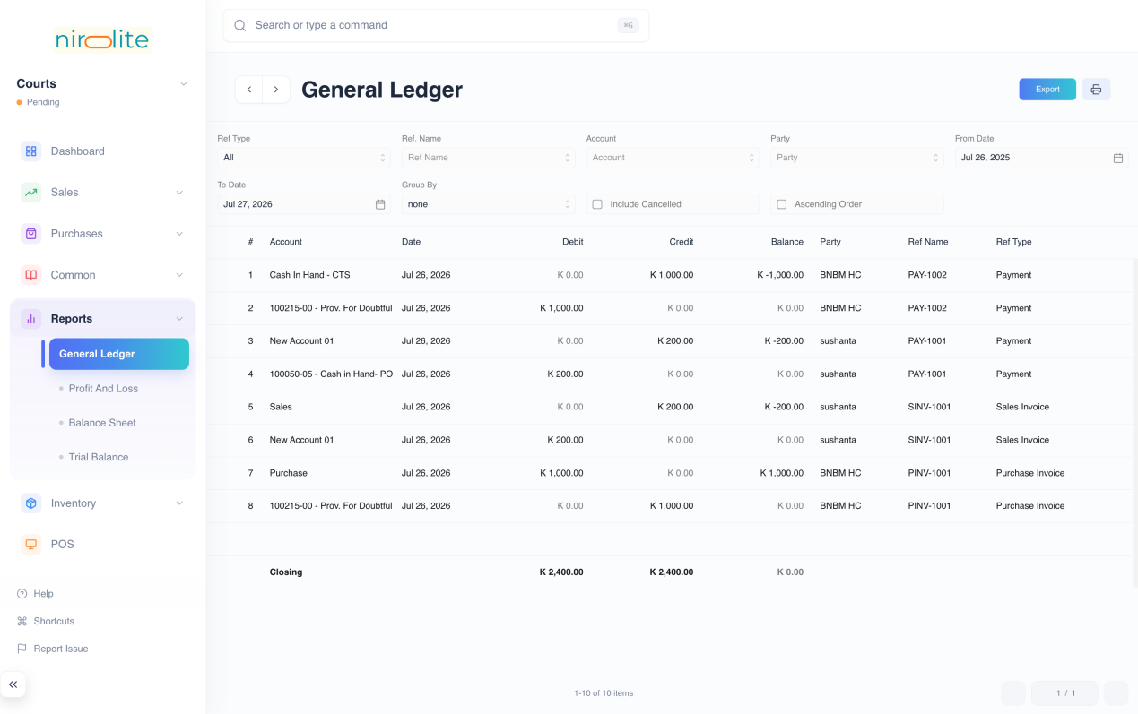
Navigate to the General Ledger from the sidebar: Report > General Ledger

Filters
The General Ledger has several filters which can help you narrow the generated report to the entries you would like to see.

Ref Type
Setting Ref Type as anything other than All will display entries only of that Transactional entry type.
Example setting Ref Type as Journal Entry will display only entries created due to Journal Entries.

Ref Name
Ref Name filter allows to display all ledger entries that were generated due to a single Transactional Entry.
To enable this you need to first set Ref Type.

Account
Selecting an Account will display only entries where an amount is being credited or debited from this account.

Party
Selecting a Party will display only entries involving them.

From Date
The initial date after which all the entries are to be displayed. The default value is one year before tomorrow.

To Date
The final date before which all the entries are to be displayed. The default value is one day after today.

Group By
Selecting a Group By option other than None groups the entry according to the selected option.
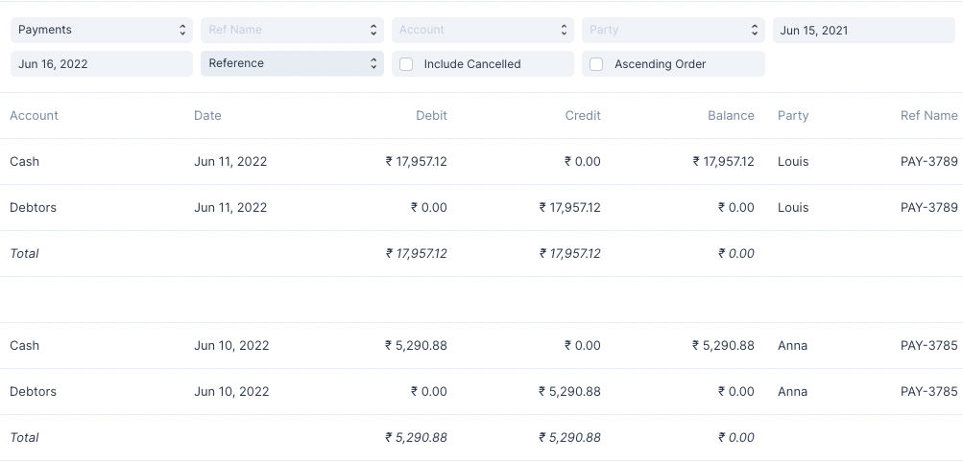
For instance setting Group By as Reference will group the entries by the Name of the transactional entry.

Include Cancelled
Checking this will include the cancelled entries in the report.
::: info Reverted Column A new column Reverted is added to indicate which of the entries have been cancelled. :::

Ascending Order
By default the entries are displayed by newest entry first, i.e. descending order of Date.
Checking this will display the entries in ascending order of entry date.

Balance Sheet
​

​
A Balance Sheet is the financial statement of a company which states assets, liabilities and equity at a particular point in time.
In Nirolite , you can view the balance sheet for your accounts based on monthly, quarterly, half-yearly, and yearly periods.
Navigate to this report from the sidebar: Reports > Balance Sheet
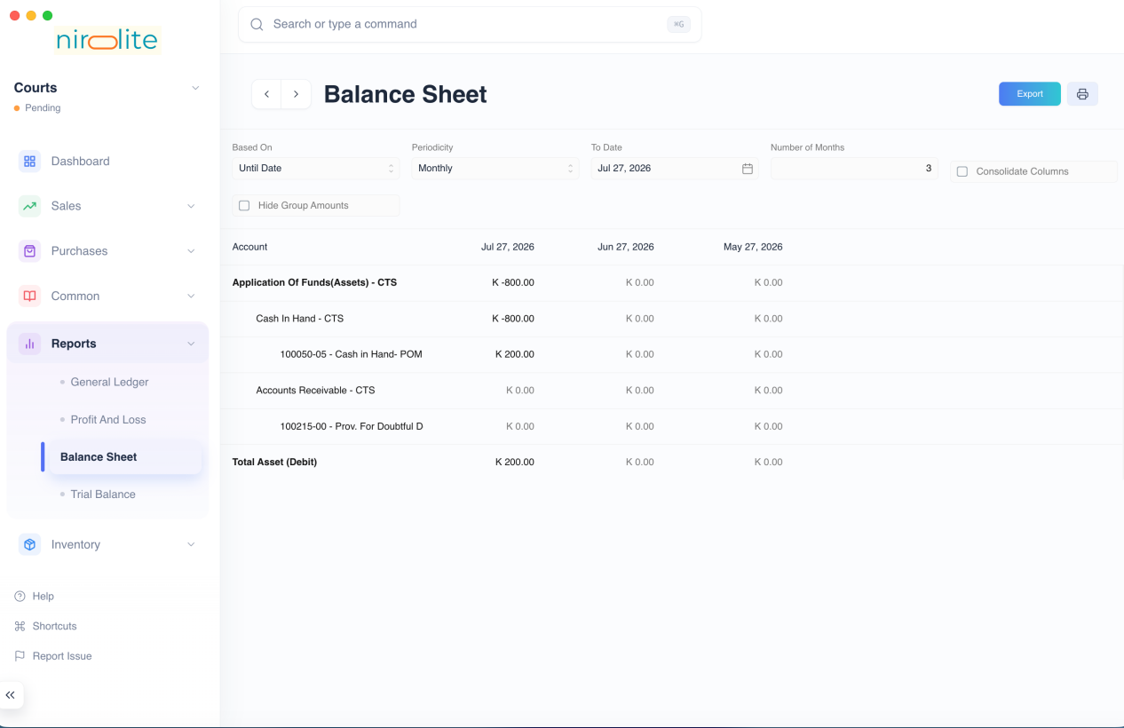

Filters
The Balance Sheet report has several filters which can help you narrow the date range between which to display the report.

Based On
This allows for toggling betwee the kind of filters used set the date range. It has 2 values:
- Until Date
- Fiscal Year

Periodicity
This selects the interval for which the Balance Sheet values have to be calculated.
Example setting this to Monthly will display columns on a monthly basis.

Date Range Filters
These filters depend on the value of Based On
Based On | Date Range Filters
Until Date | To Date and Count
Fiscal Year | To Year and From Year

To Date and Count
To Date is the final date until which the report is to be displayed, by default the values is tomorrow's date.
Count depends on Periodicity so if Count is 3 and Periodicity is Monthly then the report will display Balance Sheet columns for the last three months starting from To Date

To Year and From Year
These decide the fiscal year between which the Balance Sheet report has to be displayed. The number of columns will depend on the Periodicity.

Consolidate Columns
Checking this this will sum up all the values for each row and display a single column.

Hide Group Amounts
The Balance Sheet report format displays the group accounts such as Current Assets along with the non group accounts such as Cash and Debtors.
Group account balances depend on the non group account balances under them, group account balances are not directly updated.
So clicking on Hide Group Amounts will display only the non group account amounts making the report a bit easier to read.

Folding Rows
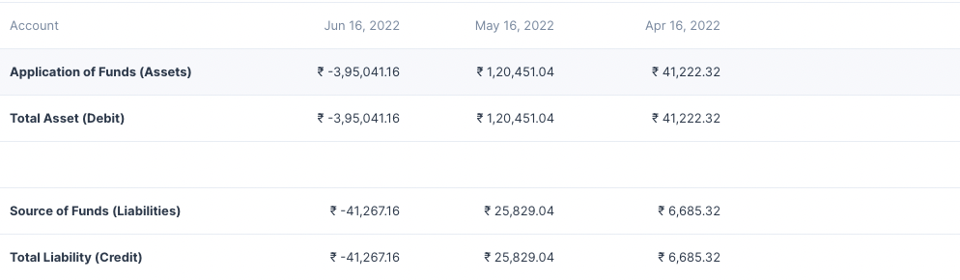
Rows in the Balance Sheet report which display group accounts can be clicked to fold all the rows underneath them.

Profit and Loss Statement
​

​
All of the money that your business earned from when it started minus the expenses that it incurred will be the total profit (or loss) the business has generated. But we aren’t interested in the total amount, but the amount that is generated last month or last quarter or last year. Hence, Profit and Loss statement is always viewed for a specific time period.
Here are some insights you can gain from this report:
- Compare this month’s profit with last month.
- Compare quarter wise or year wise profits or losses.
- Find out the total profit or loss for a specific time window.
The P&L statement for any period reflects all the income minus all the expenses in that period. At the end of the period, (a fiscal year) the total profit (or loss) goes into Owner’s Equity because the profit in the business belongs to the owners. The owner’s account is a liability to the company since the company has to pay out the profits/losses.
To check your P&L statement, navigate to it using the sidebar: Reports > Profit And Loss
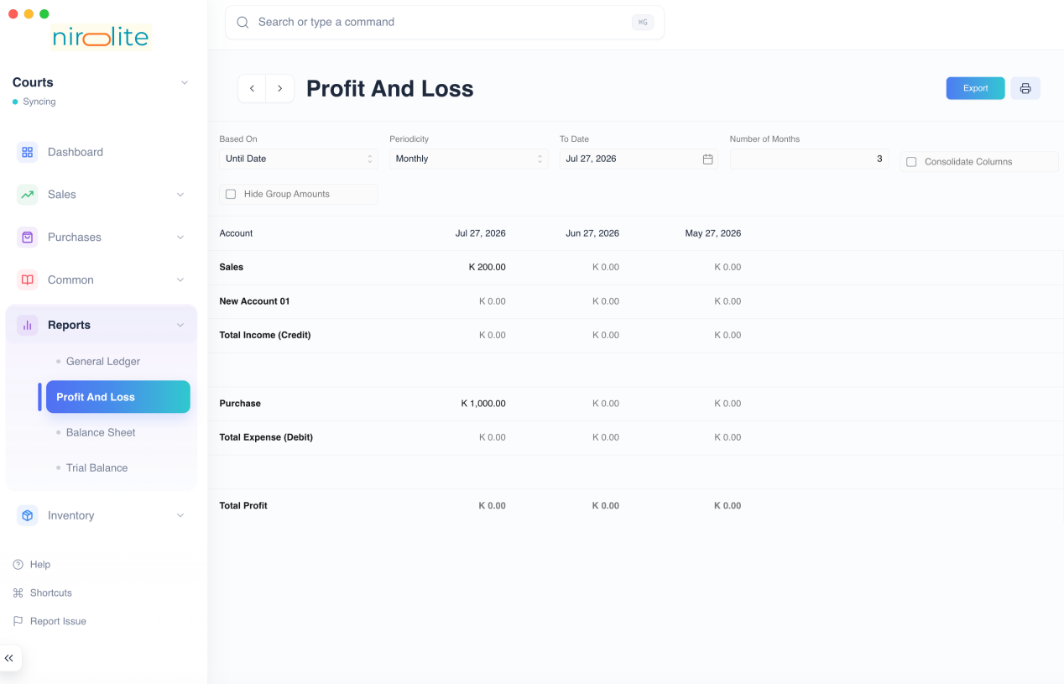
By default the Profit and Loss report will show P&L values for the last 3 months.
As you can clearly see, we have the total Income in the first part which also shows the income coming from each Income account split Monthly so you have a better understanding of your income. The same is done with the Expense section. The report is concluded by the total profit (or loss) incurred which is also split Monthly.

Filters
The Profit and Loss report has several filters which can help you narrow the date range between which to display the report.

Based On
This allows for toggling betwee the kind of filters used set the date range. It has 2 values:
- Until Date
- Fiscal Year

Periodicity
This selects the interval for which the Profit and Loss has to be calculated.
Example setting this to Monthly will display columns on a monthly basis.

Date Range Filters
These filters depend on the value of Based On
Based On | Date Range Filters
Until Date | To Date and Count
Fiscal Year | To Year and From Year

To Date and Count
To Date is the final date until which the report is to be displayed, by default the values is tomorrow's date.
Count depends on Periodicity so if Count is 3 and Periodicity is Monthly then the report will display Profit and Loss columns for the last three months starting from To Date

To Year and From Year
These decide the fiscal year between which the Profit and Loss report has to be displayed. The number of columns will depend on the Periodicity.

Consolidate Columns
Checking this this will sum up all the values for each row and display a single column.

Hide Group Amounts
The Profit and Loss report format displays the group accounts such as Direct Income along with the non group accounts such as Sales and Services.
Group account balances depend on the non group account balances under them, group account balances are not directly updated.
So clicking on Hide Group Amounts will display only the non group account amounts making the report a bit easier to read.

Folding Rows
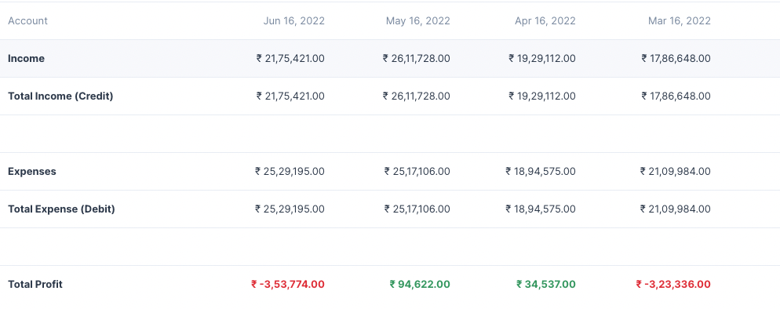
Rows in the Profit and Loss report which display group accounts can be clicked to fold all the rows underneath them.

